# OTFORD HOUSING NEEDS SURVEY

# MARCH 2025

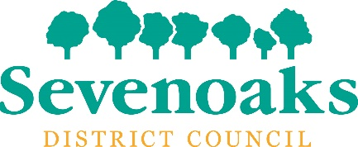

The word RACE above a graphic of two houses in a rural location

**In partnership with Otford Parish Council**

**Contents**

Introduction 3

Background Information 3

Housing in Otford Parish 4

Survey Methodology 4

Summary 4

Analysis and Results 5 - 6

Additional Indication of Local Housing Needs 6

Conclusion 6

Appendix 1 – Housing Needs Survey 7 - 10

## INTRODUCTION

Kent’s Rural and Community Housing Enabling service (RACE) undertook a local Housing Needs Survey in the Parish of Otford. The survey was undertaken as part of Sevenoaks District Council’s 5-year district wide programme of local housing needs surveys being carried out by RACE.

Housing Needs Surveys investigate the affordable housing needs of people who live in or have close ties to a parish, town or rural area and provide an independent report of that need, using a transparent and robust methodology. In addition, they investigate the needs of older households of any tenure needing to downsize or move to more suitable housing for their needs.

The Otford Housing Needs Surveys is valid for 5 years, to February 2030.

## BACKGROUND INFORMATION

The 2021 [‘Parish Councillors’ Guide to Rural Affordable Housing’](https://ruralhousingalliance.net/wp-content/uploads/2021/07/pc-guide.pdf?fbclid=IwAR1z4RXb5WSOtVl-KnYMEKNfZ2fTe-oPSRTapwZCbgZ-nqMKN18-4ArmwaA) states that ‘Across the country there is a lack of affordable housing to rent or buy in many villages, in some there is none at all. This causes hardship for people across the generations, young people just starting out on an independent life, families trying to provide for their children and older people who have lived in the village for most of their lives but whose growing frailty means they can no longer manage in their current home.’ Due to high property prices within the Sevenoaks District, the same challenges arise in more urban settlements and towns.

The Kent Rural Housing Protocol [‘A Guide to Developing Affordable Homes in Rural Communities’](https://www.kenthousinggroup.org.uk/protocols/guide-developing-affordable-homes-rural-communities/) states that ‘Within the County of Kent, most land (85%) is classed as “rural” and over 40% of businesses in Kent are based in rural areas. KHG recognise that provision of affordable housing is vital to ensure that communities continue to thrive and prosper.’

Small developments of local needs housing can provide affordable homes for local people, thereby enabling them to stay in their community, benefit from family and friends’ networks and contribute to local life. This can make a real difference to the sustainability of communities and the vitality of local services and amenities.

The housing needs of older people has been a subject of concern given the growing numbers in that age group whose needs are not being met by the market. A nine-month enquiry starting in 2017 on Housing and Care for Older People concluded in their report[1] that ‘policy makers must recognise the growing housing needs of older people living in the countryside. It recommends that Local Planning Authorities ensure provision of new homes for older people, noting the value of both the building of small village developments “perhaps six bungalows on an unused scrap of land” or larger scale retirement schemes in towns close by.’

RACE is an independent service for Kent, delivered through the [Kent Housing Group](http://www.kenthousinggroup.org.uk) and is supported by Local Authorities across Kent and Medway, including Sevenoaks District Council. RACE’s Rural Housing Enablers (RHE) will undertake a housing needs survey, analyse the results and where appropriate, help identify potential suitable sites for the development of new local needs housing. In parishes such as Riverhead this can be achieved by securing a proportion of the affordable housing to be provided on larger sites to meet the needs of local people through Local Lettings and Sales Plans.

## HOUSING IN OTFORD

The Census 2021 tells us 81.9% of households in Otford are owner occupiers, 10.4% live in social housing and 7.7% live in private rented housing or are living rent free. The housing stock comprises 5.9% flats and 94.1% houses or bungalows.

There are a total of 145 social housing properties in the Parish with the majority owned by West Kent Housing Association. Social housing is let in accordance with the Sevenoaks District Housing Register Allocation Policy or direct by the landlord Housing Association. There are currently no local needs housing schemes in the Parish where priority would be given to those with a strong local connection to Otford. This means social housing vacancies are allocated to those with a connection to the Sevenoaks District, i.e. the new tenant is unlikely to necessarily have a local connection to Otford.

High property prices in the parish, mean that some local people are unable to afford or secure a home in Otford. Searches of [www.rightmove.co.uk](http://www.rightmove.co.uk) found the cheapest open market property to buy within the parish at the time of writing this report was a 1-bedroom flat for £235,000; for a first-time buyer to afford this property an estimated 10% deposit of £23,500 would be required along with an income of approximately £47,000 based on a mortgage of 4.5 x income. The cheapest available private rented property was a 2-bedroom terraced house for £1,750 per calendar month; an income of approximately £70,000 per annum would be required to afford this property (affordability is based on rent being no more than 30% gross income).

There were no shared ownership properties for sale in Otford on the ‘Share to Buy’ website at the time of writing this report.

## SURVEY METHODOLOGY

A housing needs survey was posted to every household in the parish of Otford in February 2025. Only residents with a housing need were asked to respond; options were also provided for completion of the survey online. 1,442 surveys were distributed with 37 surveys returned.

37 completed surveys expressing a housing need were received.

## SUMMARY

Of the 37 returns, a need for up to 27 affordable homes, for the following local households was identified:

* 8 x single people
* 7 x couples without children
* 12 x families with children
* 2 of the households include an older person
* 16 of the households currently live in Otford and 11 live outside and have indicated local connections to the parish.

In addition to the above, there was a requirement for 7 x properties for older homeowners seeking to downsize or move to more suitable housing for their needs.

## ANALYSIS AND RESULTS

37 surveys were completed; 3 surveys were disallowed for the following reasons:

* 2 x duplicated surveys
* 1 x survey did not evidence a local connection to Otford

**Identified need for Affordable Housing**

| **Total Number of Affordable Homes Required** | **27** |
| --- | --- |
| **Respondent Current Location** | 16 x live in the Parish  11 x live outside the Parish but indicated a local connection |
| **Respondent Current Housing** | 9 x private rented  6 x renting from Housing Association  11 x living with relatives  1 x shared ownership |
| **Household Composition** | 8 x single people  7 x couples  12 x families with children |
| **Tenure Preference** (more than one choice allowed) | 22 x Affordable Rent*  Low-cost home ownership  8 x Shared ownership  12 x First Homes  *Social housing |
| **Level Access Housing Required** | 1 |
| **Number of older households requiring affordable housing** | 2 |
| **Specialised Housing Requirement** | 5 |
| **Number of Self-Builds required** | 0 |

Analysis shows that 7 respondents indicated having a deposit towards a low cost home ownership option.

This indicates that the majority need is for rented affordable housing, ie social housing.

**Identified need for alternative housing for older homeowners**

|  |  |
| --- | --- |
| **Total Number of Homes Required** | **7** |
| **Respondent Current Location** | 7 live in the Parish |
| **Respondent Current Housing** | 7 x Homeowner |
| **Household Composition** | 5 x single person  2 x couples |
| **Tenure Preference** (more than one choice allowed) | 6 x open market  2 x shared ownership |
| **Level Access Housing Required** | 1 |
| **Type of housing required** (more than one choice allowed) | 2 x flat  2 x House  4 x Bungalow  1 x Level access accommodation with support  5 x Co-housing for older people |

## ADDITIONAL INDICATION OF LOCAL HOUSING NEEDS

Information obtained from Sevenoaks District Council’s Housing Register indicates there are currently 52 households registered who have indicated a local connection to Otford Parish

requiring the following social housing:

* 17 x 1 bedroom
* 13 x 2 bedrooms
* 13 x 3 bedrooms
* 9 x 4 bedrooms.

## CONCLUSION

The Otford Housing Needs Survey demonstrates that at least **27 new affordable homes** are required to meet the needs of local people. From the responses received it demonstrates at least **7 open market properties for older homeowners** wanting to downsize or move to more suitable housing, are required.

The housing needs survey is an important source of evidence in measuring the housing needs of local people. Complementary indicators of housing need, including data from the Sevenoaks District Housing Register, verified local registrations of interest held by partner Housing Associations and data captured through ongoing engagement within the local community, can also provide suitable robust evidence. The Housing Needs Survey together with complementary indicators, ensure local housing needs data remains valid over a five-year period. All such evidence may be used to support the delivery of new affordable homes to meet the needs of local people.

## Appendix 1 - Paper Version of Housing Needs Survey

**A scan of the introduction to the Otford Housing Needs Survey**

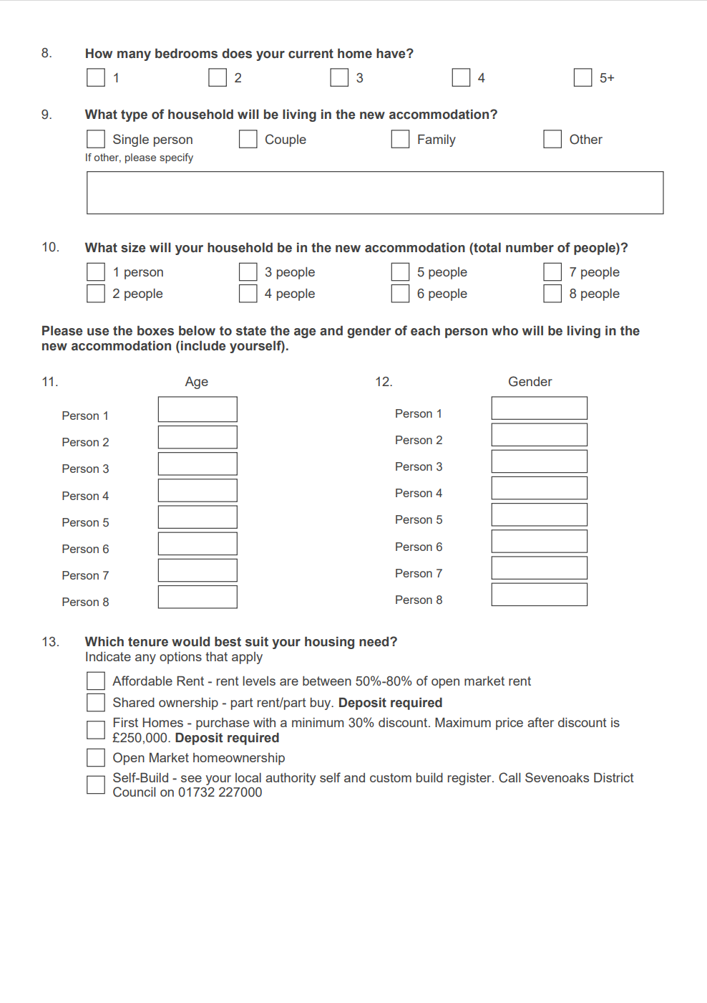

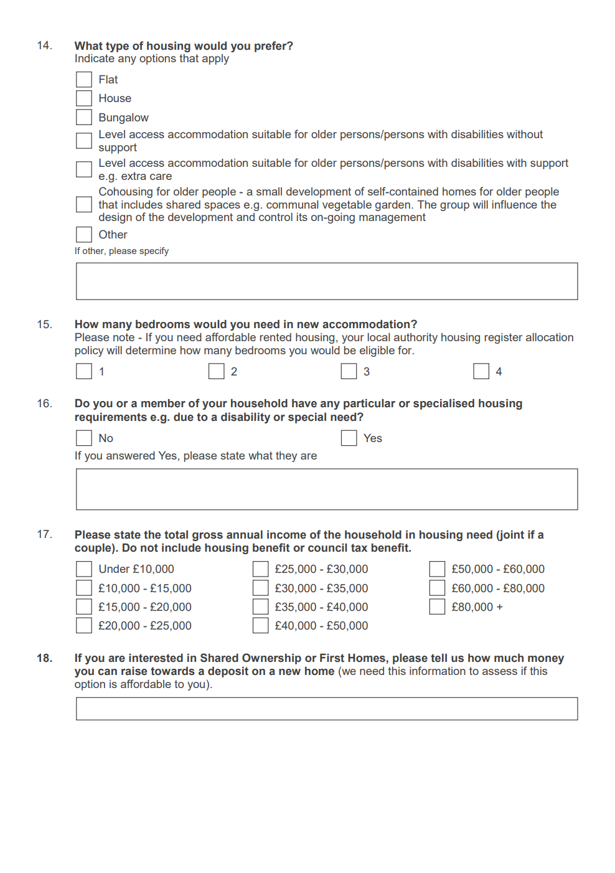

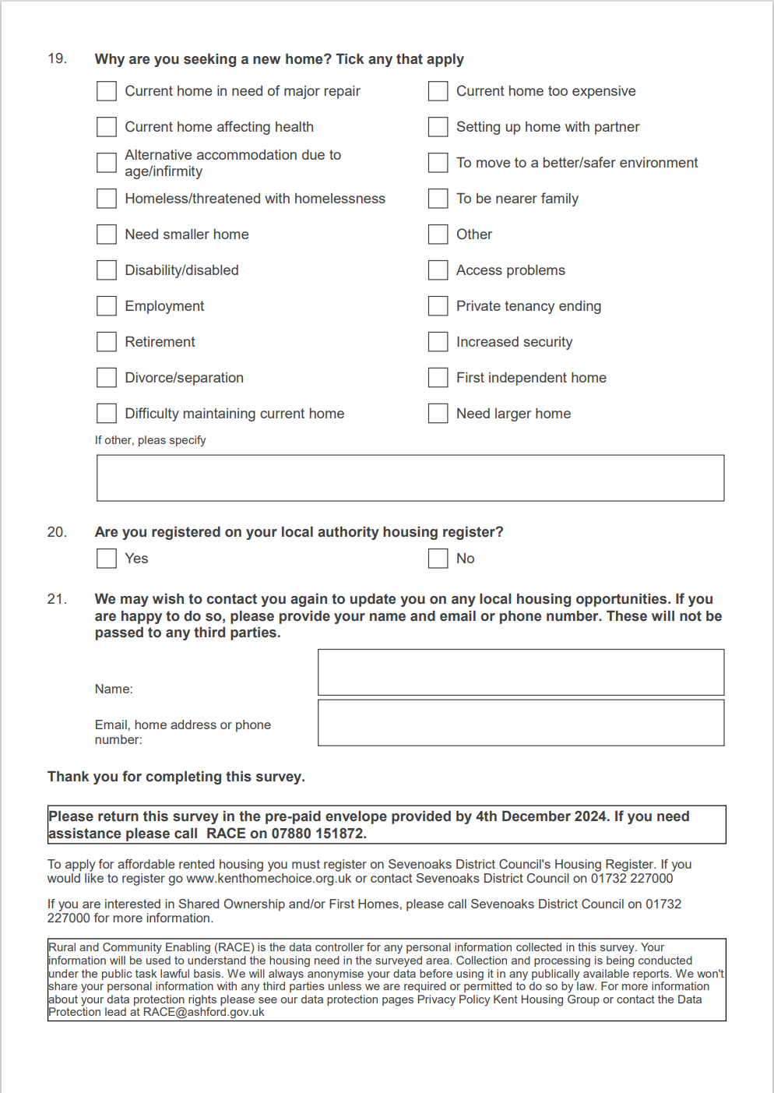

1. [Rural Housing for an Ageing Population](https://www.housinglin.org.uk/Topics/type/Rural-Housing-for-an-Ageing-Population-Preserving-Independence-HAPPI-4/): Preserving Independence. Happi 4- The Rural HAPPI Inquiry. April 2018. Jeremy Porteus