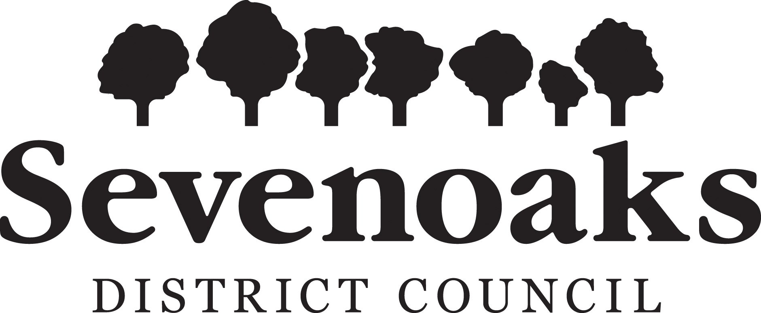

ELECTION STAFF APPLICATION FORM

Title
Surname
Forename
National Insurance Number
Date of Birth
Address & Post Code
Email address
Mobile Telephone No.

I am interested in the following role(s) (please tick):

Polling
Counting
Opening of postal votes

Please outline any relevant experience you have for these role(s):

If you are related to any Officer or Member of the Council, please give details
Do you have a full driving licence?
Have you had any driving endorsements?
Do you have your own vehicle?
Do you have any criminal convictions, other than those which are spent under the Rehabilitation of Offenders Act 1974?
If yes, please give details:
Please note that convictions which are irrelevant to the post will not be taken into account.

Would you describe yourself as having a disability (as defined by the Disability Discrimination Act 1995)?
If yes, please give details and explain any assistance or other support you would need to carry out the duties of the post you have applied for:

Employment law requires that anyone who is employed at an election must be entitled to work in the UK and that documentary evidence of this is provided. Information on suitable documents can be found on the gov.uk website – documents include a passport or a full birth certificate with supporting evidence. A copy needs to be provided, which will be retained on file and will be stored securely.

 | Yes | No
I am entitled to work in the UK and I am able to provide documentary evidence to support this

Once you have been appointed to an election role, you will need to visit the Council Offices and bring in your original document(s) for copying.

Completed forms can be scanned and emailed to elections@sevenoaks.gov.uk with the subject line of Election Staff Application Form

For information on your personal data and how it will be processed, please go to www.sevenoaks.gov.uk/dataprotection

Please be advised that if you work at elections:
- You cannot be employed (paid or voluntary) by an any political party or candidate at the election and you must be politically impartial
- Your contact details may be shared with other poll staff to facilitate the smooth running of the elections
- Your details will be shared with the Council’s payroll department
- At Parliamentary elections, your details may be shared with other neighbouring local authorities as Parliamentary constituencies cross local authority boundaries,
- Your details may be shared with other Council Services and with other public organisations, where permitted under data protection legislation, for legitimate and statutory purposes

Thank you for your interest in working on elections in the Sevenoaks District Council area.

We will manage your data in accordance with the Data Protection Act 2018. For further information on how we use your personal information, please see our privacy policy at www.sevenoaks.gov.uk/dataprotection

Please be aware that submitting an application form, does not guarantee you will be appointed to a role at every election.

Signature: |  | Date:
I certify that I have personally completed this application form, or witnessed its completion, and that the information given is correct to the best of my knowledge. I understand that canvassing Councillors or employees of the Council will disqualify me. I understand that if appointed, I will be liable to disciplinary action including dismissal and/or criminal action should I knowingly give false information. I give my permission for this personal information to be stored and processed for the purpose of arriving at a selection decision. I also give permission for the information provided to be used to form the basis of personnel records should I be appointed.

