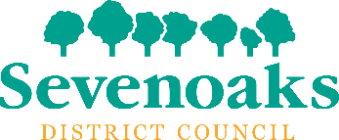

Mentoring scheme application form for young people

About the person making the application
Name:
Organisation (parents and guardians making a referral do not need to complete this question):
Telephone number:
Email address:
Date:

About the young person
Name:
Date of birth:
Contact email of young person:
Address (including the postcode):

For young people under 18 years of age – about the parent/carer/guardian
Name of parent/carer/guardian (if the young person is under 18 years old):

Contact email address of parent/carer/guardian if the young person is under 18 years old:

Why would the young person benefit from this project?

Please tell us any mental health and wellbeing support currently being provided to the young person, including the contact details of any professionals being seen:

Does the young person have any interests, hopes, aspirations that might help with initial and ongoing engagement?

□ Please tick to confirm that the young person’s parent/carer/guardian has provided consent for their details and those of the young person to be passed on to partner organisations and a mentor in order to enrol them on this project. Sevenoaks District Council will hold and use these details in accordance with its privacy policy, which can we viewed at www.sevenoaks.gov.uk/privacy.
□ Please tick to confirm that the young person named in this form has agreed to this application being made. If not, please add details below (please be aware that this scheme is unlikely to benefit any young person who has not agreed to this):

Please email this competed form to: communities@sevenoaks.gov.uk with the words ‘Support for young people’ in the subject line.
Alternatively, you can post the completed form to:
People and Places, Sevenoaks District Council, Argyle Road, Sevenoaks, Kent TN13 1HG.
If you have questions about this project or application form please email communities@sevenoaks.gov.uk.

