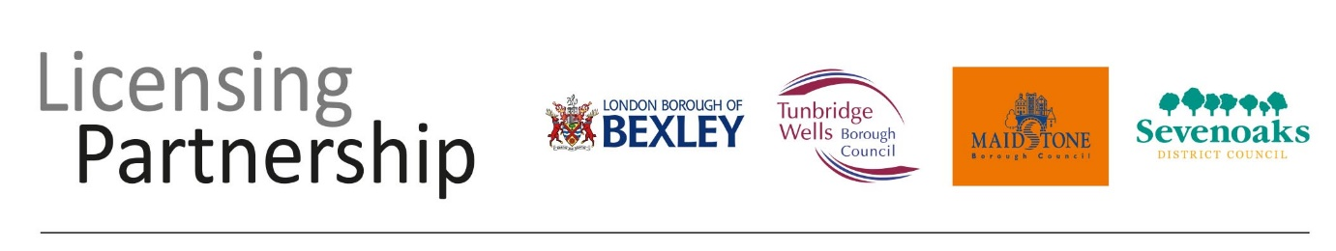
Business and Planning Act 2020 Section 2 (6)
NOTICE IS GIVEN THAT
An application has been made to *Maidstone Borough Council
*Sevenoaks District Council / *Tunbridge Wells Borough Council
*DELETE AS APPROPRIATE
(The Licensing Authority) for a
PAVEMENT LICENCE
In respects of the premise shown below.

[INSERT THE NAME OF YOUR PREMISES]

Details of the application may be inspected by contacting the Licensing Partnership on 01732 227004 or by visiting www.sevenoaks.gov.uk/licensing

Any interested party or responsible authority may make representations in respects of the application, which must be submitted in writing to the following address before the date shown below.
Licensing Partnership, Sevenoaks District Council, Council Offices, Argyle Road, Sevenoaks, Kent TN13 1HG or email licensing@sevenoaks.gov.uk
Name of Applicant | INSERT NAME
Postal address of the premises | INSERT ADDRESS
Dates by which representations must be made:
This notice remains in force from and including the day after the application was served on the Licensing Authority INSERT DATE, for seven consecutive days.

