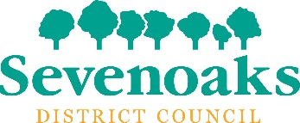

Building Control quote form
Your reference (if applicable) _____________________________________________________
About you:
Name ___________________________________________________________________________
Address _________________________________________________________________________
_________________________________________________________________________________
Telephone ________________________
Mobile ____________________________
Email _____________________________________________________

Agent details (if applicable)
Name ___________________________________________________________________________
Address _________________________________________________________________________
_________________________________________________________________________________
Telephone ________________________
Mobile ____________________________
Email _____________________________________________________

Details of the property undergoing work
Property type ____________________________________________________________________
Location _________________________________________________________________________
_________________________________________________________________________________
Proposal ________________________________________________________________________
_________________________________________________________________________________
_________________________________________________________________________________
_________________________________________________________________________________
_________________________________________________________________________________
_________________________________________________________________________________
Planning reference (if applicable) __________________________________________________
Please email or post this completed form with any relevant plans or documents to us.
- Email building.control@sevenoaks.gov.uk
- Post to Sevenoaks District Council.
Sevenoaks District Council, Building Control, Council Offices, Argyle Road, Sevenoaks, Kent TN13 1HG.

Personal data collected through this form will be held and processed in accordance with the General Data Protection Regulation, the Data Protection Act 2018 and, except where otherwise stated, in accordance with the Council’s Privacy Statement.
The Council’s Privacy Statement, including information about your data protection rights, can be found at www.sevenoaks.gov.uk/privacy.

