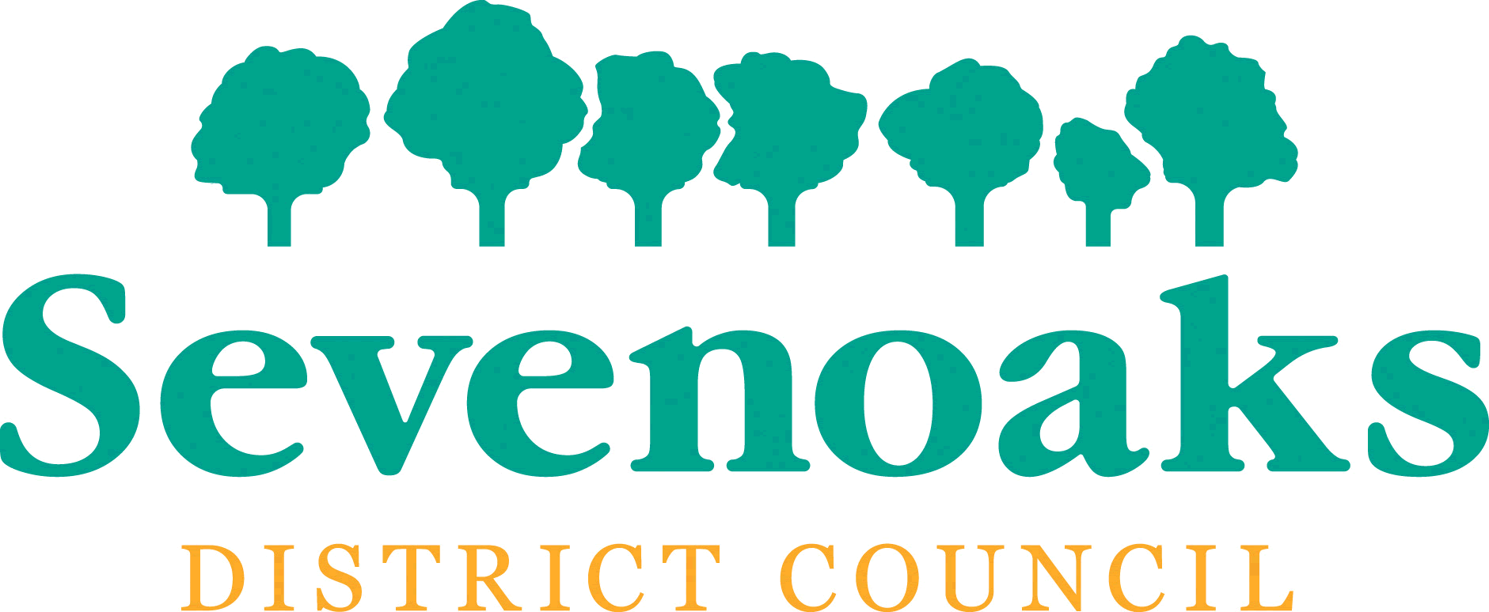
Assets of Community Value: Intention to Bid form

Name of Community Asset
Name of Community Group
Community Group Structure | A community interest group must have one or more of the following structures:  (a) A charity  (b) A community interest company  (c) A company limited by guarantee that is non-profit distributing  (d) An industrial and provident society that is non-profit distributing (these groups will be renamed as community benefit societies by the Co-operative and Community Benefit Societies and Credit Unions Act 2010 when the relevant provisions come into force)  Please state which of the above applies to your group
Contact Name
Contact Address
Email address (if available)
Day time telephone number

I confirm that I am authorised to act on behalf of the community group named above and consent to the details on this form being shared with the owner of the asset for the sole purpose of proceeding with the disposal of the above named Asset of Community Value.

Signature: |  | Date:

You can return this form by email to community.rights@sevenoaks.gov.uk, or by post to Community Rights, Transformation and Strategy Team, Council Offices, Argyle Road, Sevenoaks TN13 1HG

