Community Right to Bid
Nomination Form

February 2021
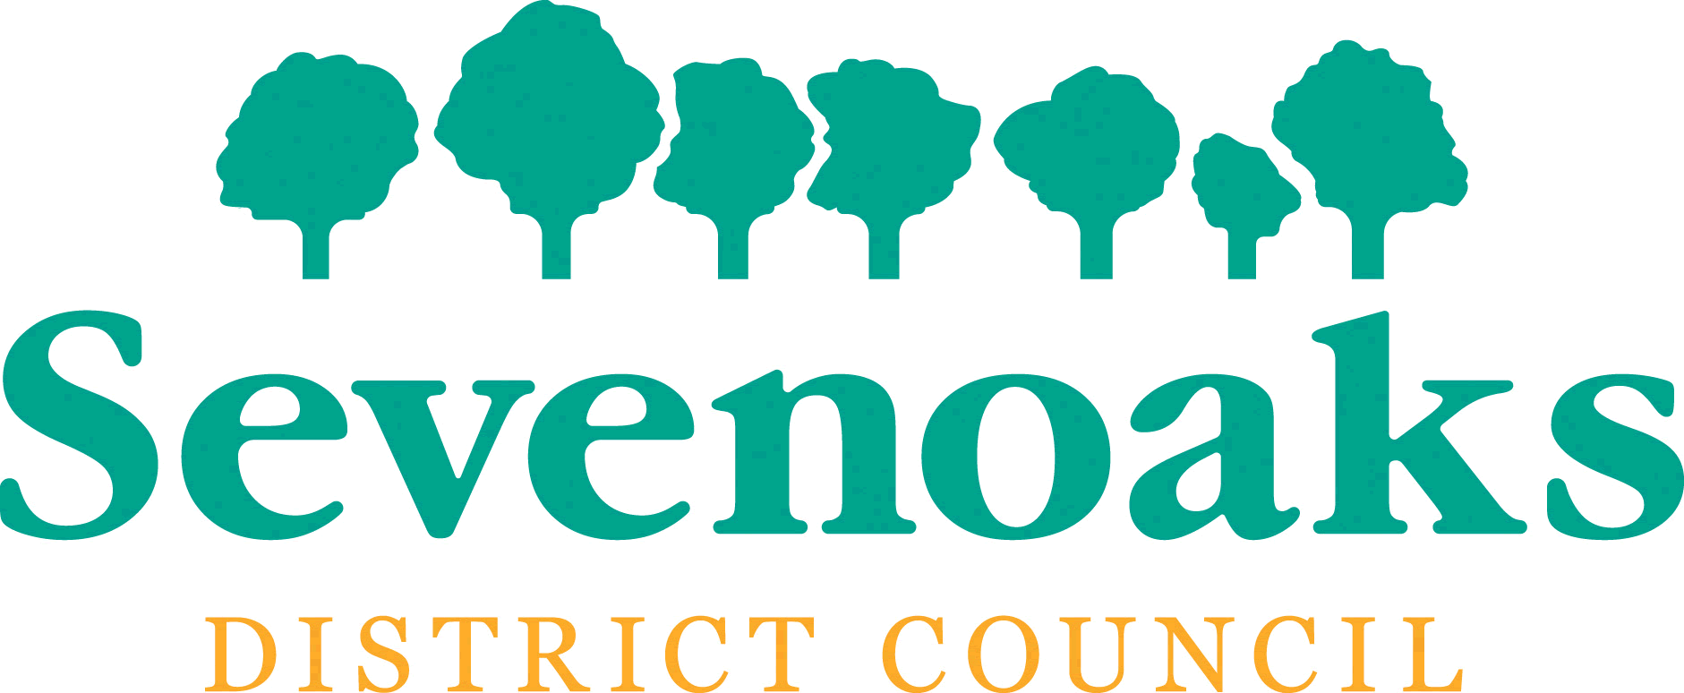
Please read Sevenoaks District Council’s Community RIght to Bid Guidance notes on the Council’s website before completing this form.

If you require a paper copy, please email communityrights@sevenoaks.gov.uk or ring the Transformation and Strategy Team on 01732 227000.

Part 1 - About the group making the nomination

Q1. Please tell us:

Name of Group making the nomination
Contact name for correspondence
Contact address for correspondence
Telephone number
Email address

Q2. Which of the following best describes your group?

Town or Parish council
Body designated as a neighbourhood forum under the Town and Country Planning Act
Unincorporated bodies with at least 21 individual members and which does not distribute any surplus it makes to its members
Charity
Company limited by guarantee which does not distribute any surplus it makes to its members
Industrial and provident society which does not distribute any surplus it makes to its members
Community interest company
Other (please write in)

If you are a Town or Parish Council please go to Q7.
For all other nominating groups, please answer the following:
Q3. Please provide evidence to demonstrate your eligibility to nominate an asset of community value: Evidence can be:

- For Charities and companies etc.: please supply memoranda and articles of association and most recently filed statements of accounts
- For unincorporated bodies, please provide a copy of your constitution, minutes of meetings and most recent accounts.
- Please attach a copy of the minute from a full meeting of your organisation confirming that the application to nominate the asset should be made
- If you are registered with Companies House please provide your registration number in the box below.

Q4. Please confirm and provide evidence that your group is wholly or partly concerned with the area covered by Sevenoaks District Council or a neighbouring local authority area.

Q5. If your group makes a financial surplus, please confirm and provide evidence that it is wholly or partly applied for the benefit of the area covered by Sevenoaks District Council or a neighbouring local authority area.

Q6. If your group is an unincorporated body please read the section on this in the Community RIght to Bid Guidance before completing this question.
I confirm that at least 21 members are included on Sevenoaks District Council’s register of electors.
My group has 21 members which are included on Sevenoaks District Council’s register of electors | Yes / No

Please provide the names and addresses on a separate sheet with your completed nomination form otherwise this may delay the processing of your nomination.

Part 2 - About the asset being nominated

Please complete all questions in this section as fully as possible to help us process your nomination and make a timely decision.

Q7. Please tell us:

Name of the asset being nominated
Address of the asset being nominated

Please provide Land Registry title documents (the title register and the title plan) for the asset being nominated that are less than one month old. These are available from the gov.uk website: https://www.gov.uk/government/organisations/land-registry We will not be able to proceed with assessing your nomination without these.

Q9: Have you been made aware that the asset is to be put on the market? Yes/No

Q10. What is the current main use of the asset?

Q11. Do you consider that the current main use of the asset furthers the following for the local community?
Social wellbeing | Yes/No
Cultural Interest | Yes/No
Recreational or sporting interest | Yes/No

Q12. If you have answered ‘Yes’ to any of the above, please explain how in the view of your group the asset does this. Please provide as much detail as possible about community use and the benefits this has. This could include descriptions of people or groups that use it, the numbers who visit, the events and kinds of activities that take place there, evidence that this is used by local people and how it benefits their social wellbeing, cultural interest or recreational and sporting interest.

If you answered ‘No’ to Q10 please complete the following questions, otherwise please go to Q16.

Q13. If you have stated that the asset does not currently further the relevant interests of the local community please state whether in the opinion of your group it did so in the recent past.

Social wellbeing | Yes / No
Cultural Interest | Yes / No
Recreational or sporting interest | Yes / No

Q14. If you answered ‘Yes’ to Q11, please provide the dates over which the asset’s main use furthered the relevant interests of the local community.

From:
To:

Q15. If you answered ‘Yes’ to Q11, please provide details of how the asset’s main use furthered the relevant interests of the local community.

Q16. How does your group anticipate that the asset has realistic prospects for a return to furthering the social wellbeing or cultural, recreational or sporting interests of the local community? Please provide any supporting documents or evidence with your nomination form.

Q17. When do you consider that the asset could return to furthering the social wellbeing or cultural, recreational or sporting interests of the local community if it was sold by the current owner?

Part 3 – Owner and occupier details
The Regulations require us to ask you to submit all of the information your group holds with regard to the names of current occupants of the land or building and the names and current or last-known addresses of all those holding a freehold or leasehold estate in the land.

Please complete this section as fully as possible to help us process your nomination as quickly as possible.

Q18. I am able to provide details about…

The current owner | Yes / No
OR
The last known owner | Yes / No

Q19. Please tell us:

Name of the owner
Contact address for the owner

Q20. Please provide details of the current, lawful, occupiers of the asset.

Name of the occupier
Contact address for the occupier
If there is more than one occupier please provide the details of additional occupiers on a separate sheet with your completed nomination form.
Q21. If the owner of the land is not the freeholder, please provide the names and addresses of any holders of the freehold estate.

Name of the owner
Contact address for the owner

If there is more than one additional freeholder please provide the details of additional freeholders on a separate sheet with your completed nomination form.

Q22. Please provide the names and addresses of any holders of the leasehold estate other than the owner

Name of the owner
Contact address for the owner

If there is more than one additional leaseholder please provide the details of additional leaseholders on a separate sheet with your completed nomination form.

Q23. Please provide any further information to support why you feel Sevenoaks District Council should conclude that the asset you have nominated is of community value.

You are welcome to attach additional sheets or pages of evidence in support of your nomination.

Q24. I certify that the information supplied in this nomination form is correct to the best of my knowledge and belief

Name
Title / Role
Signature
Date

Please check before returning the form: have you have provided the following?

- Evidence of your organisation’s eligibility to nominate?
- Land Registry documents?
- Any documents or other evidence that outline how the asset has realistic prospects for the future

Please return the completed nomination form to:

Community Right to Bid
Transformation and Strategy Team
Sevenoaks District Council
Argyle Road
Sevenoaks
Kent
TN13 1HG

Or submit by e-mail to: community.rights@sevenoaks.gov.uk

For further information about how the Council will process your information, please visit our Privacy Notice at www.sevenoaks.gov.uk/privacy.

